The benchmark costs are presented as groups that are based on the common elements of
revegetation projects:
Project planning and management;
Transport costs;
Mechanical and chemical site preparation methods;
Fencing costs;
Seed and direct seeding costs;
Seedlings and seedling establishment costs;
Tree guard costs; and
Other costs less commonly incurred in revegetation work.

Costs of a revegetation project can vary significantly between regions. The
differences depend on the revegetation methods used in different regions.

The most costly components of revegetation projects are usually
fencing materials,
seedlings (in projects where seedlings are used)
labour (required for most projects).
On some sites which have significant coverage of competing vegetation, the costs of spraying herbicides can be a significant proportion of total revegetation costs.
Where tree guards are used they are also a large proportion of total project costs.

Several types of costs decrease on a per hectare basis as the size of the revegetation project increases.
These include fencing,
site preparation,
line/boom spraying of herbicides
direct seeding,

In general, direct seeding is a cheaper method of revegetation than establishing seedlings,
while assisted natural regeneration costs less than either of the above methods.

Costs may vary depending upon bioclimatic region, being more expensive in:
the moist tropical regions
the central arid regions
the warm moist temperate with hot summer regions.
The increased cost is due primarily to the different methods used rather than to differences in the cost of particular revegetation methods between regions. In more remote regions, the impact of transport costs for transporting materials and personnel to the site increases the costs of revegetation considerably.

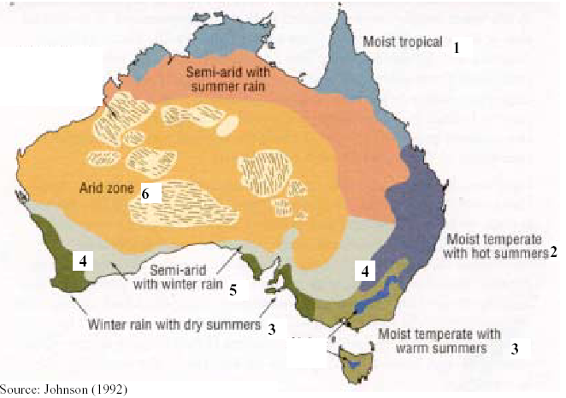

BIOCLIMATIC TYPES

$25 per hour but $15 per hour to account for “in kind” labour

