Planning a Revegetation Project

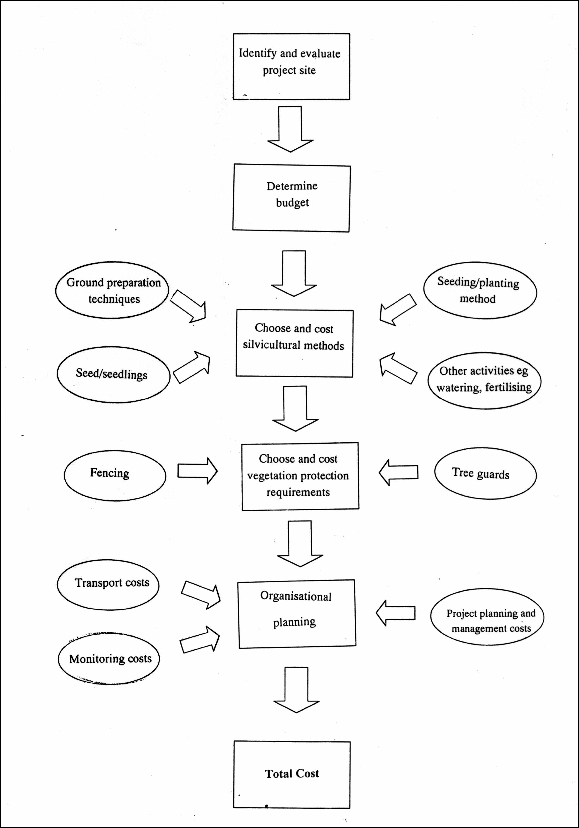
Source: The Cost of Revegetation Final Report Jacki Schirmer* and John Field**
* ANU Forestry and FORTECH ** ANU Forestry, Greening Australia, 2000

