Bioregion
Victoria have been arranged by bioregions, which are a landscape-scale approach to classifying the environment using a range of attributes such as climate, geomorphology, geology, soils and vegetation. There are 28 bioregions identified within Victoria.

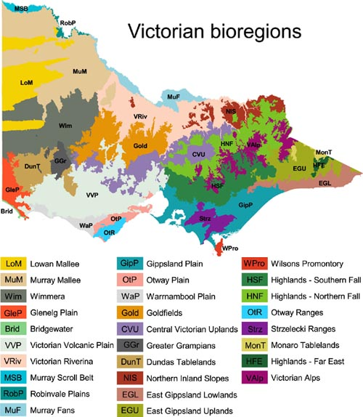

Bioregional Conservation Status (BCS)
An assessment of the conservation status of the native vegetation type (EVC) in the context of a particular bioregion, taking account of how commonly it originally occurred, the current level of depletion and the level of degradation of condition typical of remaining stands.

Legend for Bioregional Conservation Status of Ecological Vegetation Classes (EVC)
STATUS |  | CRITERIA
Presumed Extinct | X | Probably no longer present in the bioregion (the accuracy of this resumption is limited by the use of remotely - sensed 1:100 000 scale woody vegetation cover mapping to determine depletion - grassland, open woodland and wetland types are particularly affected).
Endangered | E | Contracted to less than 10% of former range; OR  Less than 10% pre-European extent remains; OR  Combination of depletion, degradation, current threats and rarity is comparable overall to the above:  - 10 to 30% pre-European extent remains and severely degraded over a majority of this area; or  - naturally restricted EVC reduced to 30% or less of former range and moderately degraded over a majority of this area; or  - rare EVC cleared and/or moderately degraded over a majority of former area.
Vulnerable | V | 10 to 30% pre-European extent remains; OR  Combination of depletion, degradation, current threats and rarity is comparable overall to the above:  - greater than 30% and up to 50% pre-European extent remains and moderately degraded over a majority of this area; or  - greater than 50% pre-European extent remains and severely degraded over a majority of this area; or  - naturally restricted EVC where greater than 30% pre-European extent remains and moderately degraded over a majority of this area; or  - rare EVC cleared and/or moderately degraded over a minority of former area.
Depleted | D | Greater than 30% and up to 50% pre-European extent remains; OR  Combination of depletion, degradation and current threats is comparable overall to the above and:  - greater than 50% pre-European extent remains and moderately degraded over a majority of this area.
Rare | R | Rare EVC (as defined by geographic occurrence) but neither depleted, degraded nor currently threatened to an extent that would qualify as Endangered, Vulnerable or Depleted.
Least Concern | LC | Greater than 50% pre-European extent remains and subject to little to no degradation over a majority of this area.

Ecological Vegetation Class (EVC)
A hierarchical system of classification of plant communities has been developed in Victoria over the past decade in order to classify vegetation into units that are both ecologically meaningful and useful for natural resource managers. The classification that has been adopted in Victoria includes Ecological Vegetation Classes (EVCs) which are defined by a combination of floristics, lifeform, position in the landscape, and an inferred fidelity to particular environments. Each EVC includes a collection of floristic communities (i.e. groups based on co-occurring plant species) that occur across a biogeographic range, and although differing in species, have similar habitat and ecological processes operating. Approximately 300 EVCs have been described for Victoria.

An ecological vegetation class consists of one or a number of floristic communities that appear to be associated with a recognisable environmental niche, and which can be characterised by a number of their adaptive responses to ecological processes that operate at the landscape scale level. Each ecological vegetation class is described through a combination of its floristic, life-form and reproductive strategy profiles, and through an inferred fidelity to particular environmental attributes.

Floristic Community
A group of species that are similar in terms of structure and responses to major environmental variables such as landform, geology, soil, aspect, slope and rainfall. A combination of these variables provides suitable habitat for species that are characteristic of a Floristic Community. Consequently, where a combination of variables is repeated in the landscape at a local scale and broad scale, a particular Floristic Community can occur.
EVC Benchmark
EVC benchmarks have been developed as standard vegetation-quality reference points that are applied in carrying out vegetation quality assessments. Represents the average characteristics of a mature and apparently long-undisturbed stand of the same vegetation type.

An EVC benchmark is standard vegetation-quality reference point relevant to the vegetation type that is applied in assessments. Represents the average characteristics of a mature and apparently long-undisturbed state of the same vegetation type. EVC benchmarks have been developed to assess the vegetation quality of the EVCs at the site scale in comparison to a 'benchmark' condition. Each EVC benchmark contains a range of information necessary for conducting a vegetation quality assessment.
Habitat Hectare
A site based measure of quality and quantity of native vegetation that is assessed in the context of the relevant native vegetation.
Index of Wetland Condition
The Index of Wetland Condition (IWC) is designed for naturally-occurring wetlands without a marine hydrological influence. The IWC includes a measure to assess the quality of wetland vegetation in the wetland Ecological Vegetation Class. IWC is based on an adaptation of the Habitat Hectare model more suited to scoring wetland vegetation.

Mapping Units
A mapping unit is an area mapped at 1:100 000, that includes one or more Ecological Vegetation Class (EVC) . Where there are more than one EVC the mapping unit, the unit may be called a mosaic, complex or an aggregate. In general, these mapping units have been established because finer resolution of the vegetation could not be achieved at the scale of mapping.
EVC aggregate - The term aggregate is applied to an EVC mapping label where the EVC represents a generalised label for wetlands occurring within a given ecological context (e.g. saline, brackish or freshwater lakes; billabongs; mineralised drainage-lines on grey-clay basalt derived soils). While the range of EVCs, which can be variously expressed in these situations, can be determined, the scale and intricacy can be prohibitive to resolution of the component EVCs, especially for the purpose of broader-scale mapping.
EVC complex - EVC complexes are mapping units with influences of two or more defined EVCs that cannot be differentiated at the site scale.
EVC mosaic - EVC mosaics are mapping units containing two or more defined EVCs that cannot be differentiated at the scale of mapping.
EVC 'variants' - Variants of an EVC are sometimes used in the bioregional benchmarks. This is necessary where variants of an EVC containing different life form characteristics and occupying different environments are known to exist within a bioregion. This is indicated by the code "_61", "_62" etc. after the EVC number in the EVC benchmark list.
EVC generic - A generic mapping unit largely based on the Departments pre-1750 wetland mapping layer (wet_1788) and that was used in some of the early EVC mapping in Victoria. This will be progressively be replaced following the recent revision of the statewide EVC wetland typology. A generic wetland lookup table provides information on the component EVCs that may be found within each of the generic wetland mapping units.
Simplified Native Vegetation Groups
Similar Ecological Vegetation Classes (EVC) have been assigned to a simplified native vegetation group. Some groups have been further divided into sub-groups for more convenient management and illustration of state-wide data. There are 20 simplified native vegetation groups with a total of 35 sub-groups.

